Day Performance Similarities of Multiple Listed Companies

A Case Study

# Idea

Some companies lists on more than one stock exchange, they are called “dual-listed” or “cross-listed” depending on the legal implementation (this distinction is not taken into account in the following).  
If the stock exchanges are in different time zones, then the stocks of one company are traded twice in 24 hours and we want to investigate if the day performance on the previous stock exchange has some predictive signal for the following one. To assess the presence and usefulness of such a signal a simple trading model is defined and applied over the past data.

# Stock Exchange Selection

The trading times of the stock exchanges should not overlap, so that a completed trading day can be used as input. New York lies in the GMT-5 time zone so appropriate stock exchanges can be found in Far East. I have selected the Bombai Stock Exchange (BSE) in India in the time zone GMT+5.5; the choice was by random.

# Companies Selection

After some online searching Google returned the following site with companies which are listed on NASDAQ/NYSE and BSE: <http://www.goodreturns.in/classroom/2015/06/indian-companies-listed-on-nasdaq-or-nyse-369055.html>  
As next step I tried to find the according stock symbols on NYSE/NASDAQ and BSE. I could not find or match all of them on both stock exchanges and so the following companies remained:

|  |  |  |  |  |  |  |
| --- | --- | --- | --- | --- | --- | --- |
| **Company** | **US Stock_Exch.** | **IN Stock Exch.** | **Sector** | **US Symbol** | **IN Symbol** | **Comment** |
| ICICI Bank | NYSE | BSE | Banks | IBN | ICICIBANK |  |
| Infosys | NYSE | BSE | Software & Computer Services | INFY | INFY |  |
| Vedanta Limited | NYSE | BSE | Indust.Metals & Mining | VEDL | VEDL |  |
| Tata Motors | NYSE | BSE | Industrial Engineer | TTM | TATAMOTORS |  |
| Videocon d2h | NASDAQ | BSE | TV Services | VDTH | VIDEOIND | VIDEOIND is the group. |
| Wipro | NYSE | BSE | Software & Computer Svc | WIT | WIPRO |  |

Videocon d2h (VDTH) is a subsidiary of the group Videocon Industries Limited (VIDEOIND) and therefore does not match the precondition of a multiple listed company, but I obtained also this data to have a look on such a case. Additionally data for VDTH are not available until 2015, because VDTH was established then.

# Data Gathering and Preprocessing

Daily historic stock data of the last ten years can be downloaded on the websites of the stock exchanges as CSV files:

* NASDAQ and NYSE: <http://www.nasdaq.com/quotes/historical-quotes.aspx>
* BSE: <http://www.bseindia.com/markets/equity/EQReports/StockPrcHistori.aspx?scripcode=512289&flag=sp&Submit=G>

We have to consider two cases for our intention. We can trade in New York and use the day performances of the BSE as indicators or vice versa. The goal was to provide one table where each row is an observation:

|  |  |  |  |  |  |  |  |  |  |  |
| --- | --- | --- | --- | --- | --- | --- | --- | --- | --- | --- |
| **flip** | **us_symbol** | **in_symbol** | **us_date** | **in_date** | **us_open** | **us_close** | **in_open** | **in_close** | **us_perf** | **in_perf** |
| in->us | WIT | WIPRO | 13.07.2007 | 13.07.2007 | 4,2865 | 4,2974 | 519 | 512,6 | 0,00254 | -0,01233 |
| in->us | WIT | WIPRO | 16.07.2007 | 16.07.2007 | 4,2513 | 4,2215 | 514,9 | 500,7 | -0,00701 | -0,02758 |
| in->us | WIT | WIPRO | 17.07.2007 | 17.07.2007 | 4,2052 | 4,2459 | 500 | 505,6 | 0,00968 | 0,01120 |
| in->us | WIT | WIPRO | 18.07.2007 | 18.07.2007 | 4,2594 | 4,2134 | 505 | 504,45 | -0,01080 | -0,00109 |
| in->us | WIT | WIPRO | 19.07.2007 | 19.07.2007 | 4,2513 | 4,2838 | 501 | 505,4 | 0,00764 | 0,00878 |
| in->us | WIT | WIPRO | 20.07.2007 | 20.07.2007 | 4,2377 | 4,1836 | 507 | 505,05 | -0,01277 | -0,00385 |
| in->us | WIT | WIPRO | 23.07.2007 | 23.07.2007 | 4,2134 | 4,2405 | 505,05 | 507,8 | 0,00643 | 0,00545 |
| in->us | WIT | WIPRO | 24.07.2007 | 24.07.2007 | 4,2025 | 4,17 | 508,1 | 506,5 | -0,00773 | -0,00315 |

The column flip describes the trading scenario, “in->us” stands for trading in the US with the data from India as indicator. The value “us->in” marks the other case. The table only contains observations where the counterpart stock exchange has provided data in the previous 24 hours. Dates with a longer time lap, because of weekends or public holidays, are omitted. For the “in->us” case this means that the Indian and the US date are the same. For the “us->in” case this means that the Indian date is one day after the US date. The day performance is calculated with the formula: (close_price – open_price) / open_price.

# Idealistic Trading Model

To evaluate the usefulness/worth of the previous day performance we define a simplified trading model. If the day performance at the previous stock exchange is greater than zero then we buy the stock with the opening price and sell it with the closing price, which means, that we assume the day performance on the local stock exchange as the trading win of loss. The trigger if we trade is the day performance of the stock at the previous, remote stock exchange.

# First Glance

Applying this simple trading model to our data from 2008-01-01 to 2017-01-01 gives the following result:

Case “in->us”, trading at NASDAQ/NYSE:

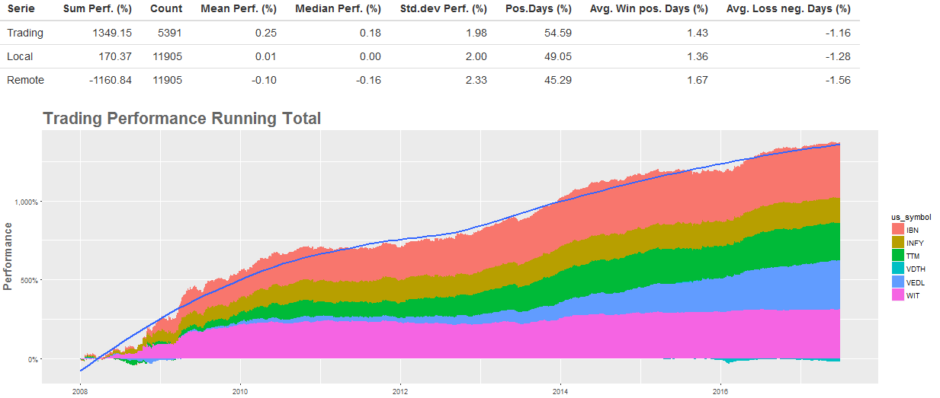

The trading model generates a gain of 1349.15% - that is impressive. The table above the chart gives some key metrics, which I want to explain shortly. The rows describe three different trading scenarios. The “Trading” row reflects our trading model. The “Local” row reflects the summary of the day performance of all dates in the dataset (in the time range) at the local stock exchange (in this case NASDAQ/NYSE). The “Remote” row reflects the summary of the day performances of all dates in the dataset (in the time range) at the remote stock exchange (in this case BSE).  
The columns are described below:

|  |  |
| --- | --- |
| Sum Perf.(%) | Sum of the day performances in present. |
| Count | Count of rows. When multiplied by 2 it gives the number of necessary trades (buying and selling). |
| Mean Perf.(%) | The mean performance of the day performances in percent. |
| Median Perf.(%) | The median performance of the day performances in percent. |
| Std.dev Perf (%) | The standard deviation of the day performances in percent. |
| Pos.Days(%) | The percent of positive day performances. |
| Avg. Win pos. Days(%) | The average day performance of positive day performances in percent. |
| Avg. Loss neg. Days (%) | The average day performance of zero or negative day performances in percent. |

The comparsion of the “Trading” row with the “Local” row shows, that the trading model has more positive dates, i.e. more dates with a win. Additionally the average gain on positive dates is greater than the average win of all positive days and the average loss on negative days is smaller than the average loss on all negative dates. In combination this effect is strong enough to result in a gain of 1349%.

Case “us->in”, trading at BSE:

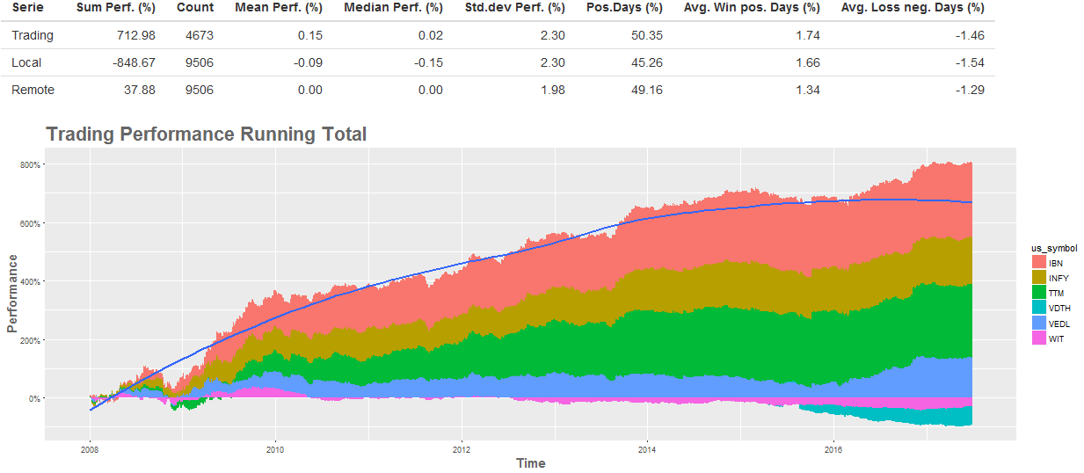

The total gain in India is ca. 712%. Far not as big as the gain in New York but still remarkable.   
Noticeable is the performance difference between the trading model and the local row. A trading on each date in the dataset would have resulted in a loss of ca. 849%, whereas the trading model yield some substantial profit.

Overall, it is obvious that the day performance of the previous, remote stock exchange contains a valuable signal and that it is worth to take a closer look.  
In total the performance growths for the case “in->us” and “us->in”, but there are some interesting details. For example is the performance of WIT and VDTH negative in the “us->in” case and in the “in->us” case WIT seems to yield no gain since 2010.  
Before we dive deeper into the data, we take a closer look at the correlation of the stock prices of the companies.

# Stock Price Correlations

A scatterplot with the US and IN stock prices from 2008-01-01 to 2017-07-01 looks somewhat weird:

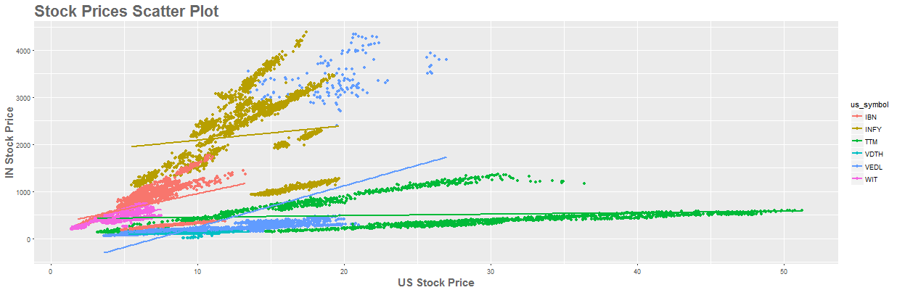

The reasons for the different patches of the same company are stock splits performed in India. For example, IBN performed one at the end of 2015.

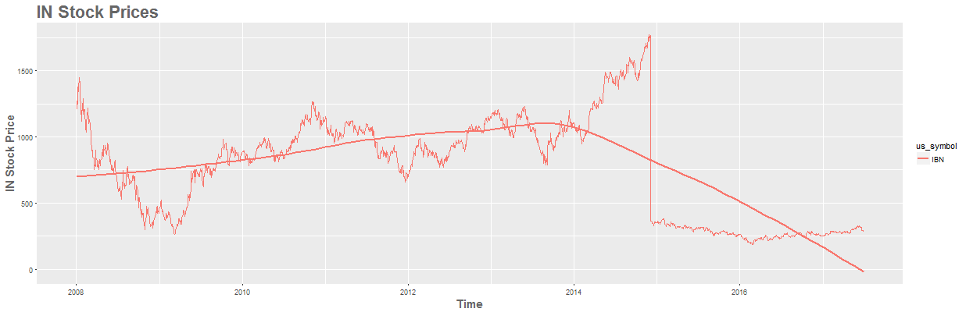

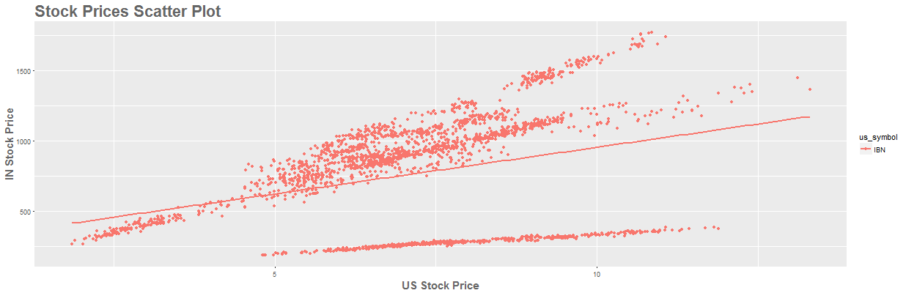

The time range from 2008-01-01 to 2014-09-01 is strongly correlated:

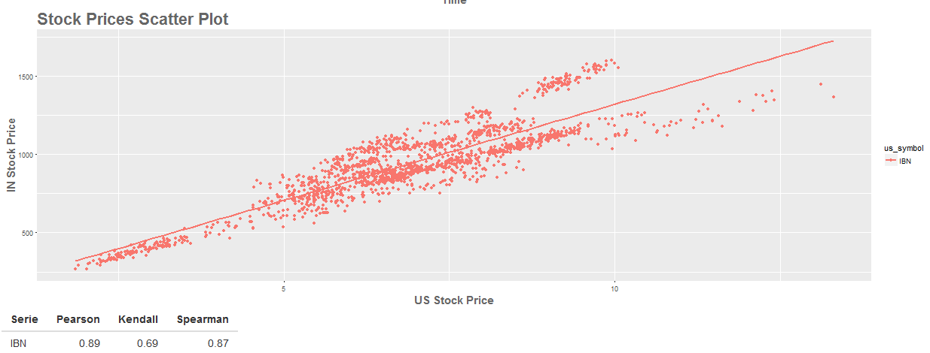

Also the time range afterwards (2015-01-01 – 2017-07-01):

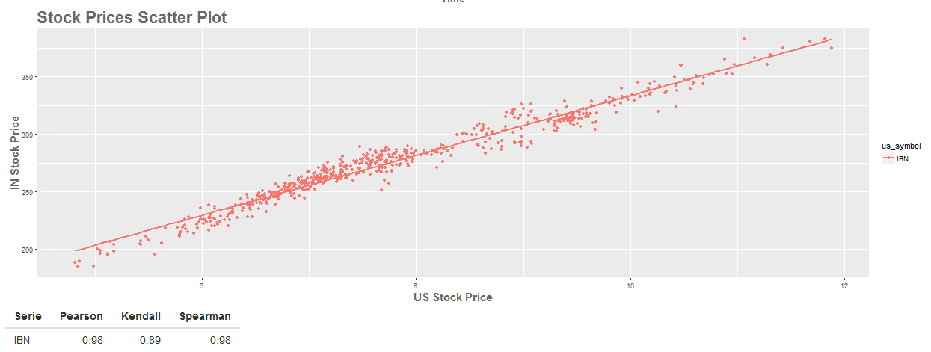

Considering the stock splits and comparing each company separately and without the split events the Pearson correlations of the stock prices are always greater than 80%, except VDTH, where the correlation factor is only 73%. However, considering the circumstance that the US company VDTH is a subsidiary of the Indian group VIDEOIND it is still strong.

# Day Performance Correlations

After the stock price correlations we turn to the day performance correlations, i.e. the relationship between the day performance of the previous stock exchange and the current/local one.

The correlations per company in the time range 2008-01-01 to 2017-07-01 are as following:

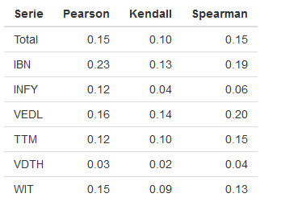

The correlation factors are much weaker than the ones of the stock prices. However, there is a measureable relationship, except for VDTH.   
The total correlation over all companies is 15%.

To investigate the correlations in more detail we need to enhance our toolset, therefore a sliding correlation and sliding trading performance was implemented.